Question:
Solve the given set of linear equations using the Gaussian Elimination Method in Python.
Aim:
Write a Python program to demonstrate to solve a set of linear equations using Gaussian Elimination Method.
Program:
# Gaussian elimination with partial pivoting and printed row operations
# Solve the system:
# x1 + 10x2 - x3 = 3
# 2x1 + 3x2 + 20x3 = 7
# 10x1 - x2 + 2x3 = 4

from copy import deepcopy

# Augmented matrix [A | b]
A = [
[1.0, 10.0, -1.0, 3.0],
[2.0, 3.0, 20.0, 7.0],
[10.0, -1.0, 2.0, 4.0]
]

def print_matrix(M, msg=None):
if msg:
print(msg)
for r in M:
print("[" + " ".join(f"{val:10.6f}" for val in r) + "]")
print()

def swap_rows(M, i, j):
M[i], M[j] = M[j], M[i]
print(f"R{i+1} <-> R{j+1}")
print_matrix(M)

def scale_and_add(M, src, k, dest):
# Perform R_dest = R_dest - k * R_src
print(f"R{dest+1} = R{dest+1} - ({k:.6f})*R{src+1}")
n = len(M[0])
for c in range(n):
M[dest][c] -= k * M[src][c]
print_matrix(M)

# Work on a copy
M = deepcopy(A)
print_matrix(M, "Initial augmented matrix [A | b]:")

n = len(M)

# Forward elimination with partial pivoting
for col in range(n):
# Partial pivot: find row with max abs value in column
pivot_row = max(range(col, n), key=lambda r: abs(M[r][col]))
if pivot_row != col:
swap_rows(M, pivot_row, col)
pivot = M[col][col]
if abs(pivot) <= 1e-12:
raise ValueError("Zero pivot encountered")

# Eliminate below
for row in range(col + 1, n):
factor = M[row][col] / pivot
scale_and_add(M, col, factor, row)

print("Upper-triangular matrix after forward elimination:")
print_matrix(M)

# Back substitution
x = [0.0] * n
for i in range(n - 1, -1, -1):
rhs = M[i][n - 1]
for j in range(i + 1, n):
rhs -= M[i][j] * x[j]
x[i] = rhs / M[i][i]

print("Solution vector:")
for i, xi in enumerate(x, 1):
print(f"x{i} = {xi:.8f}")
Result:
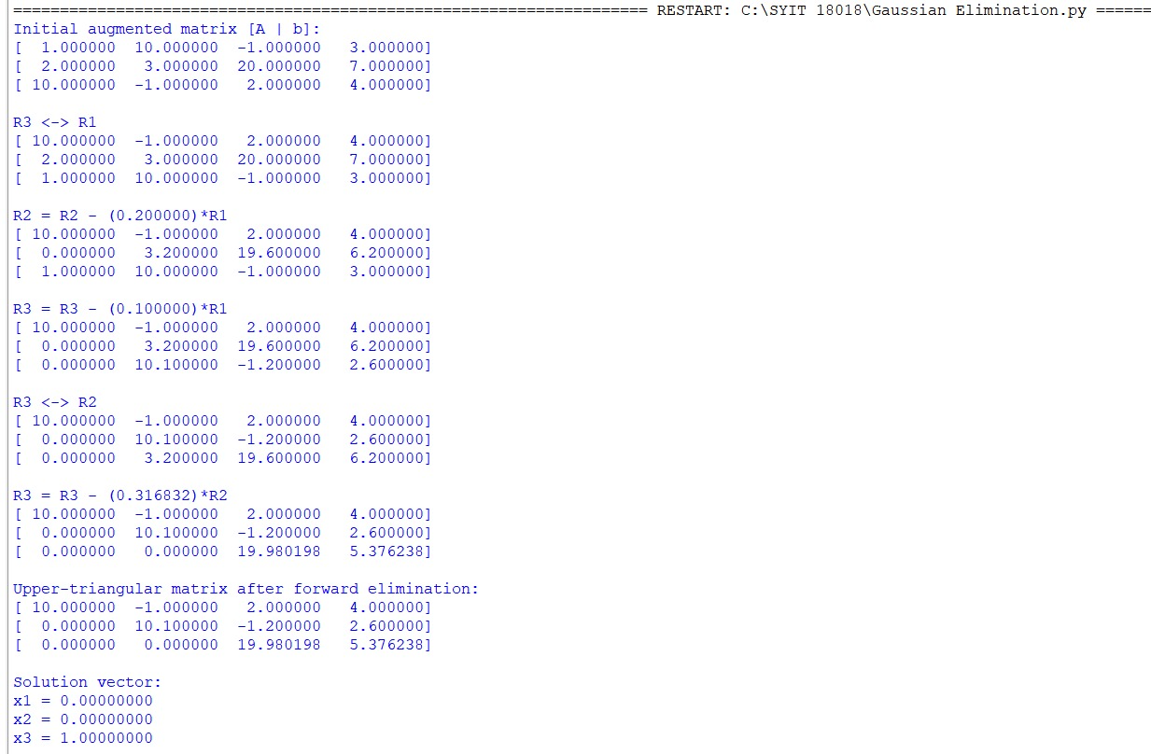
Conclusion:
The above Python program has been executed successfully.

